- Simulate a small network with switches and multiple devices.
Use ping to generate traffic and observe the MAC address table of the switch.
Capture packets using Wireshark to analyze Ethernet frames and MAC addressing.

Cisco Packet Tracer:
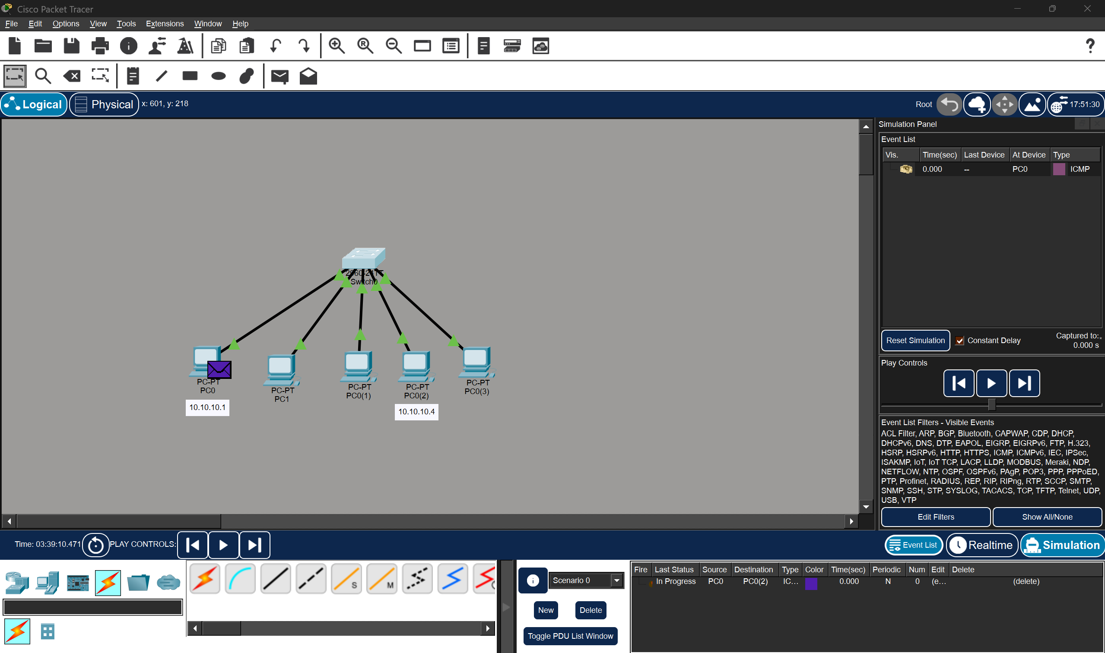
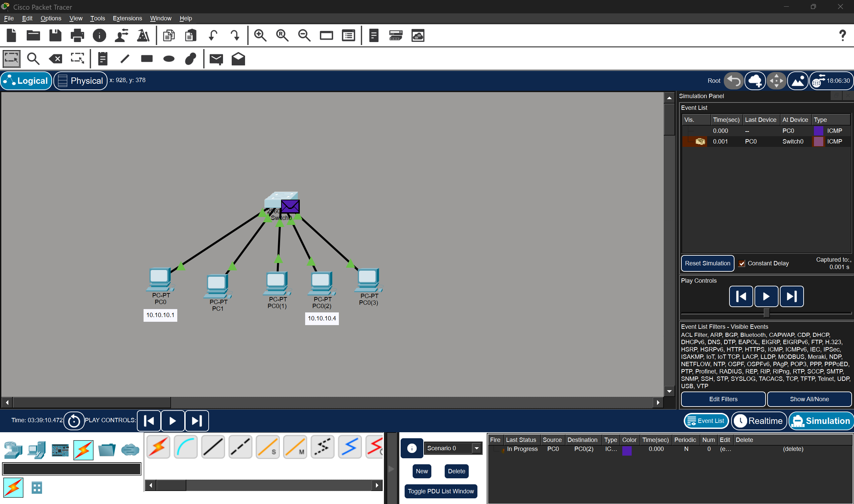
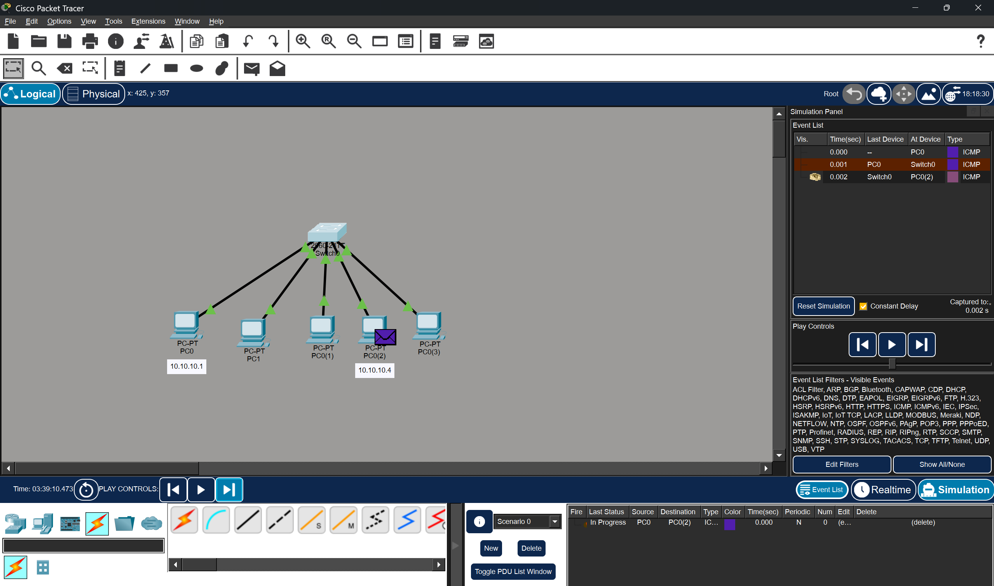
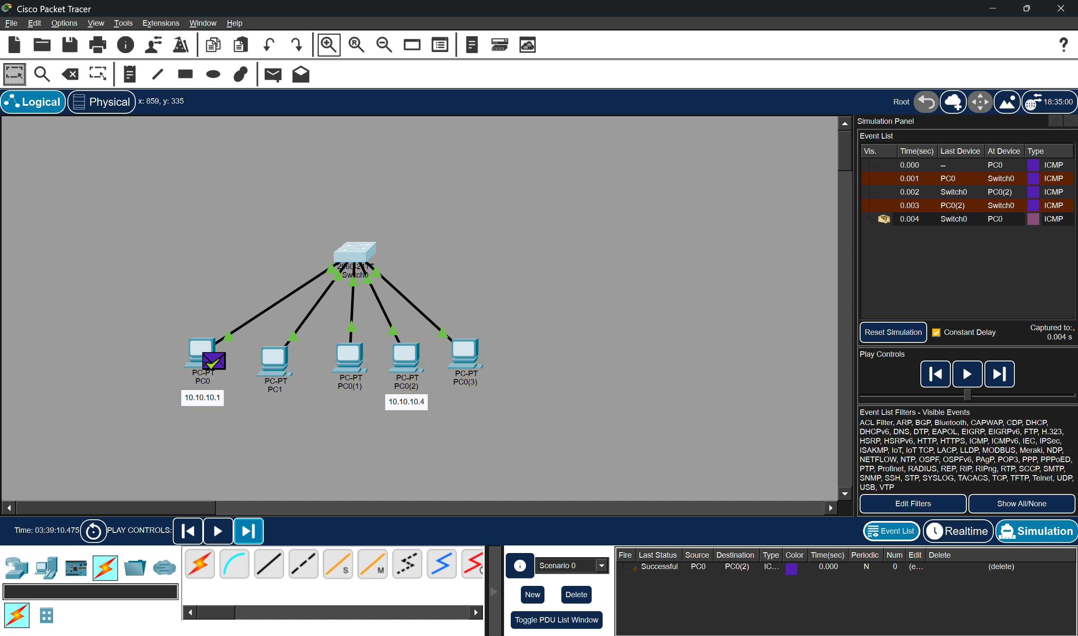

Simulation is done and the packet is sent by PC0 to PC0(2). During simulation, the ping command is given in terminal of PC0.
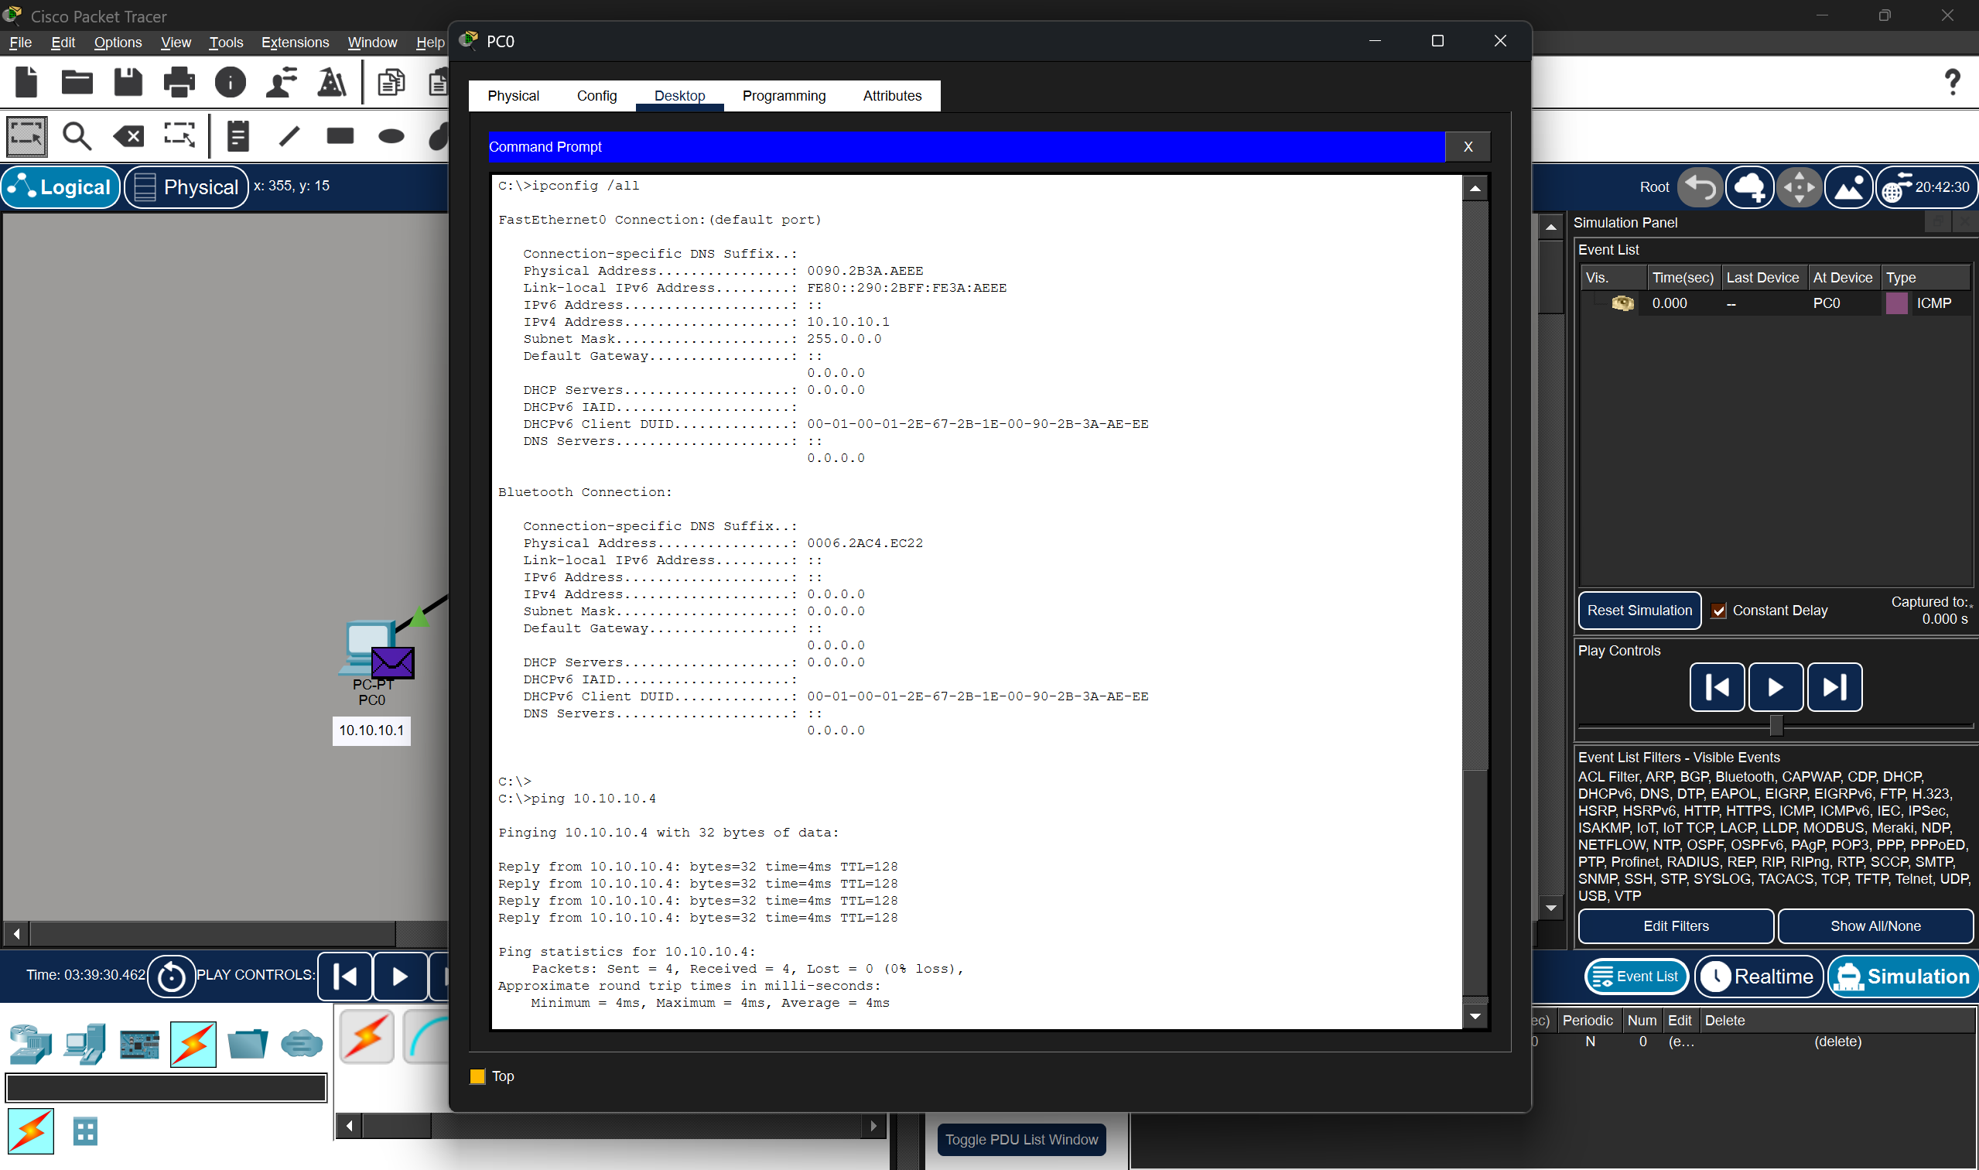
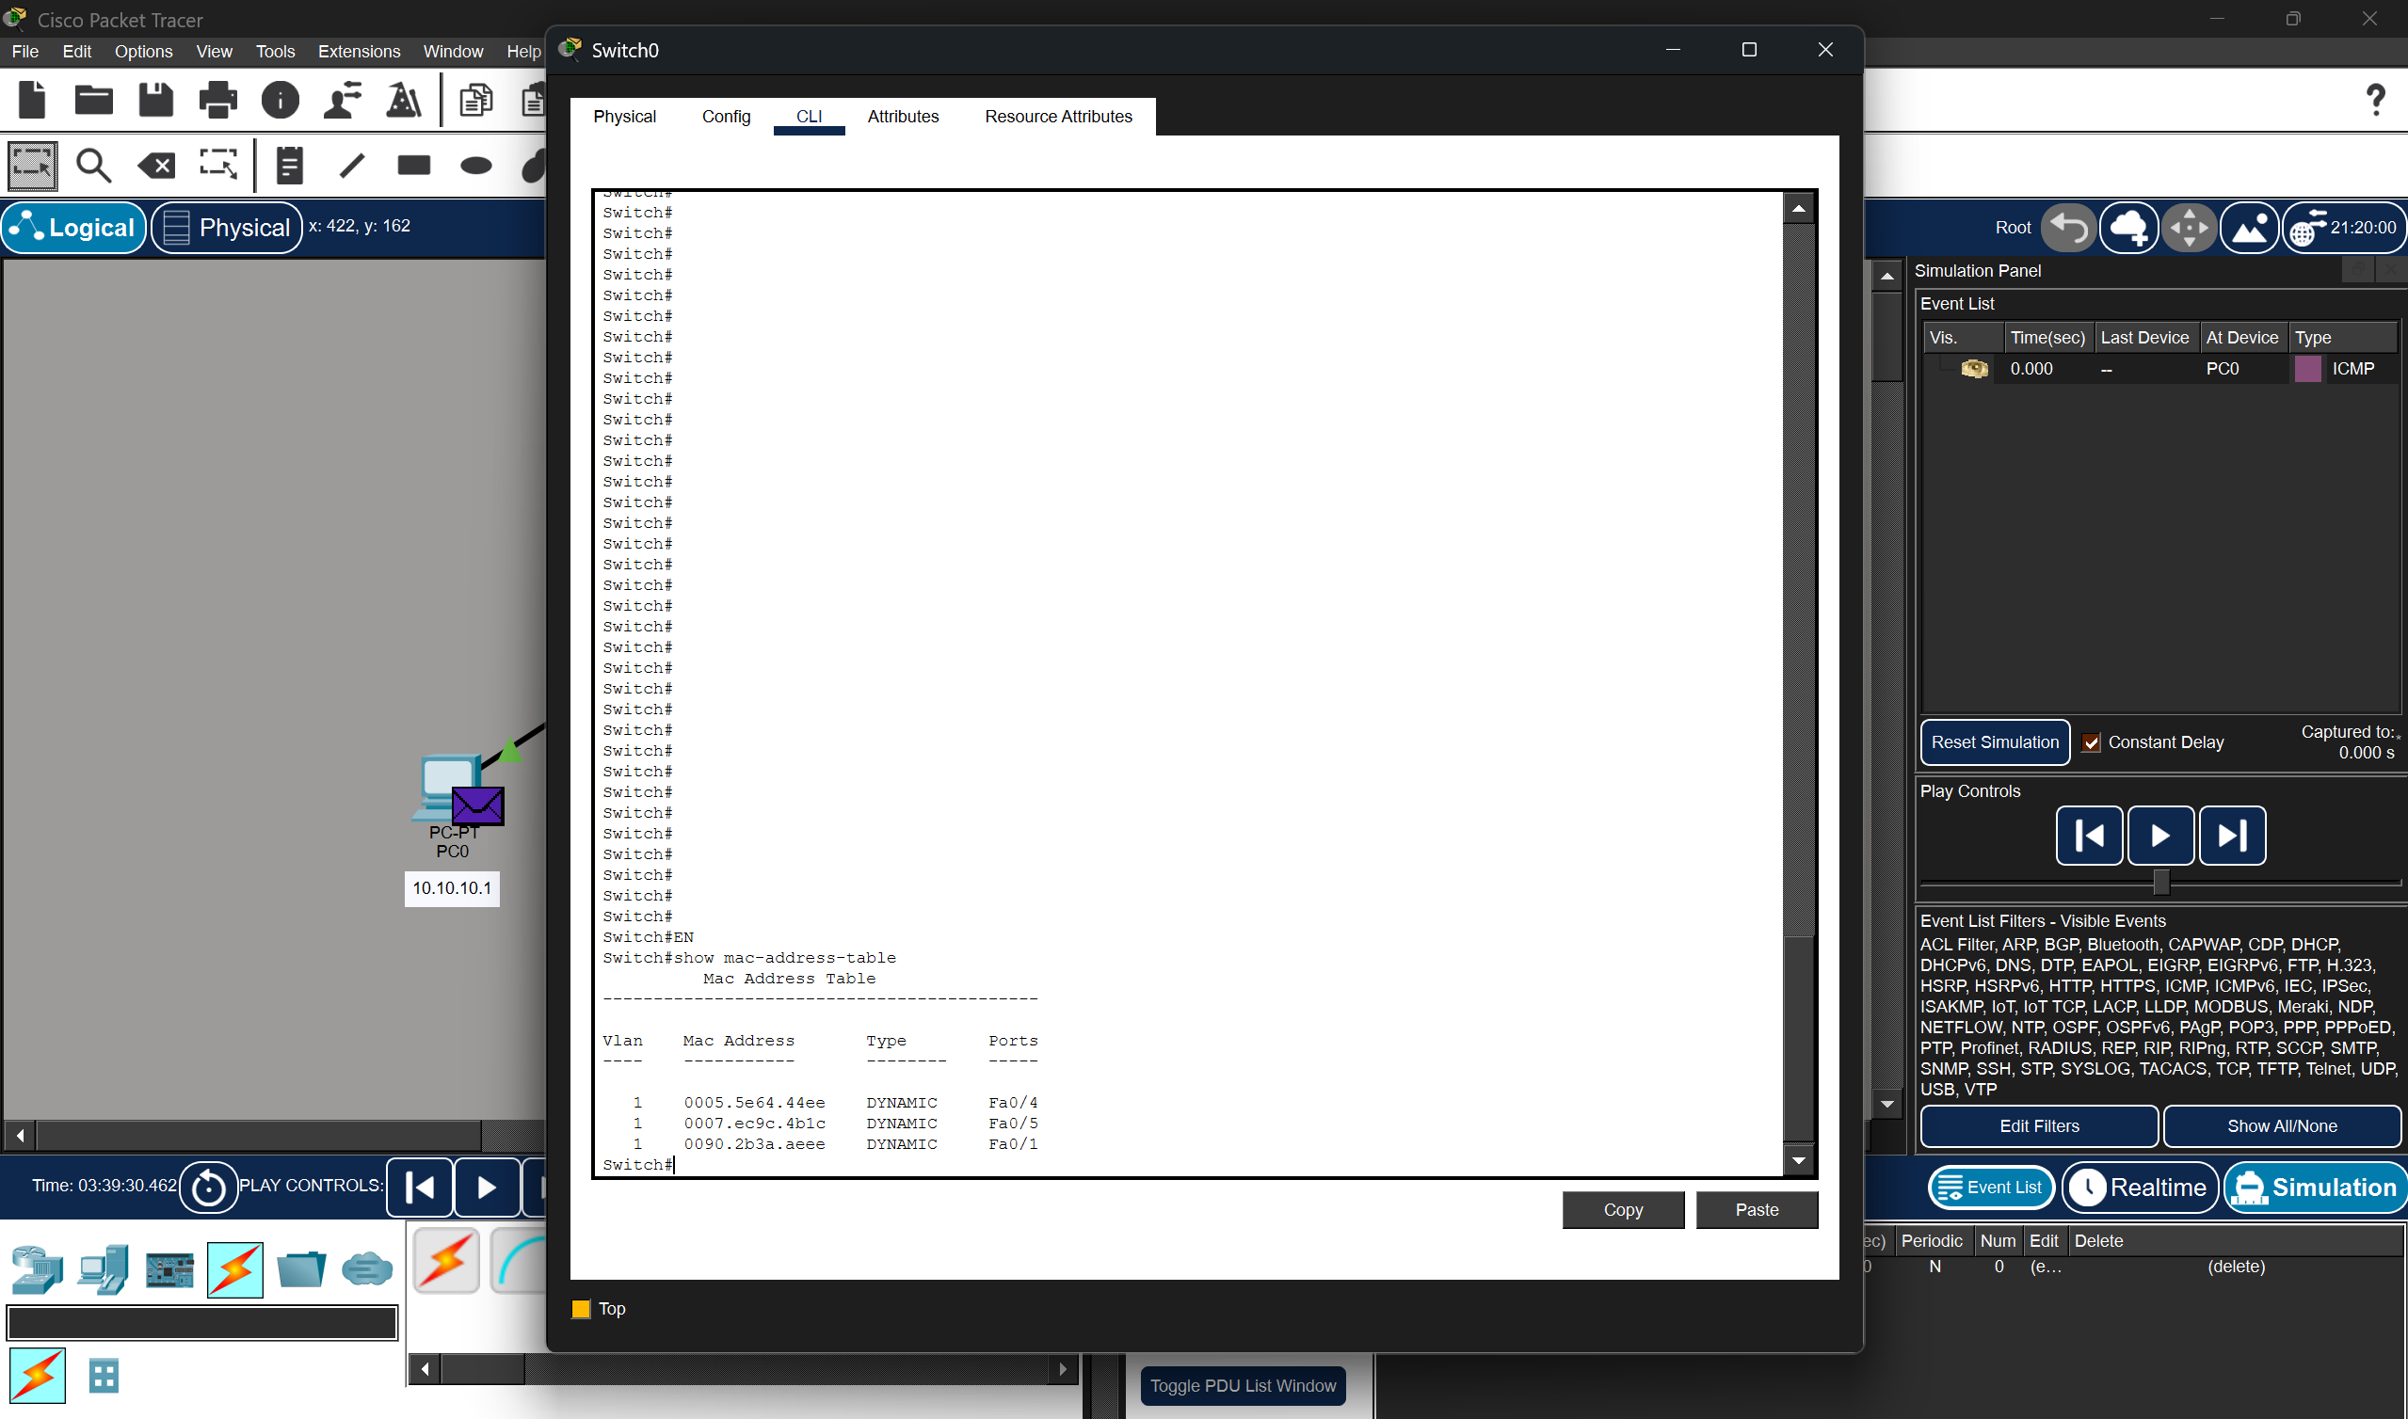

To view ping command of PC0 and mac address table of Switch.

Gns3:
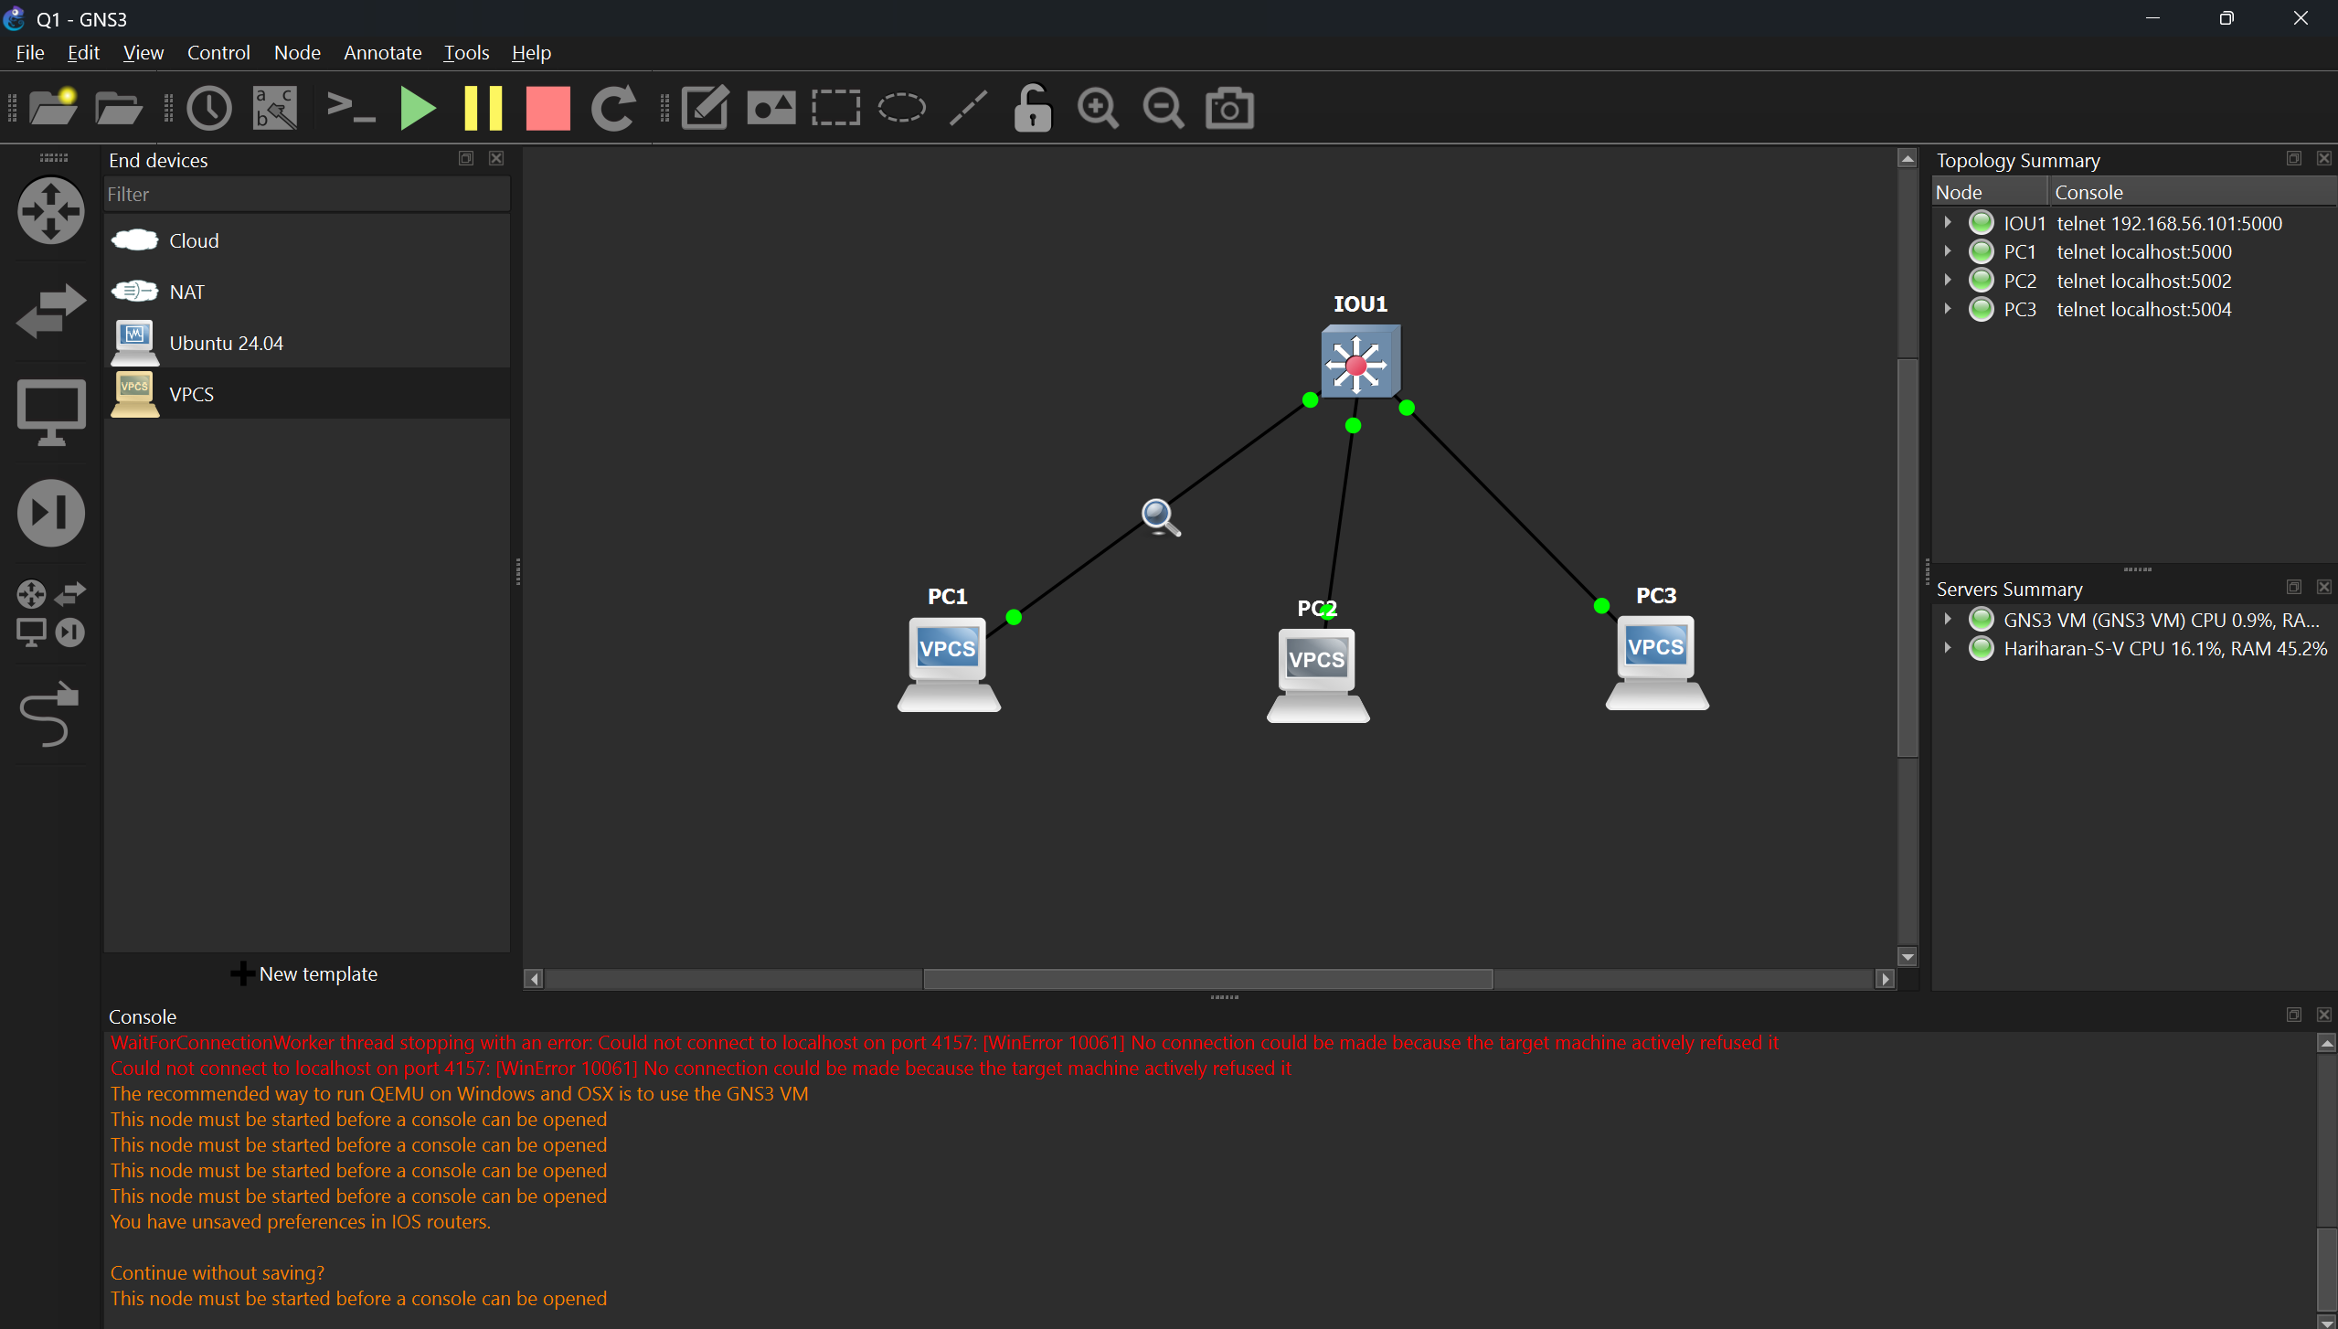
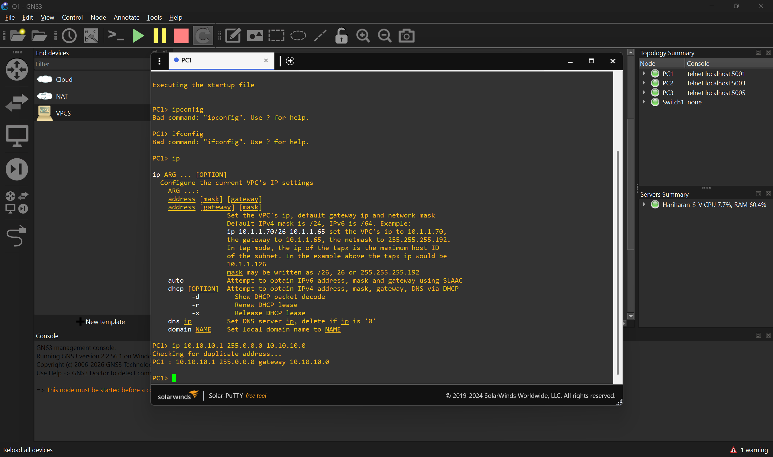

IP address, Subnet mask and Default Gateway is configured in each PCs.
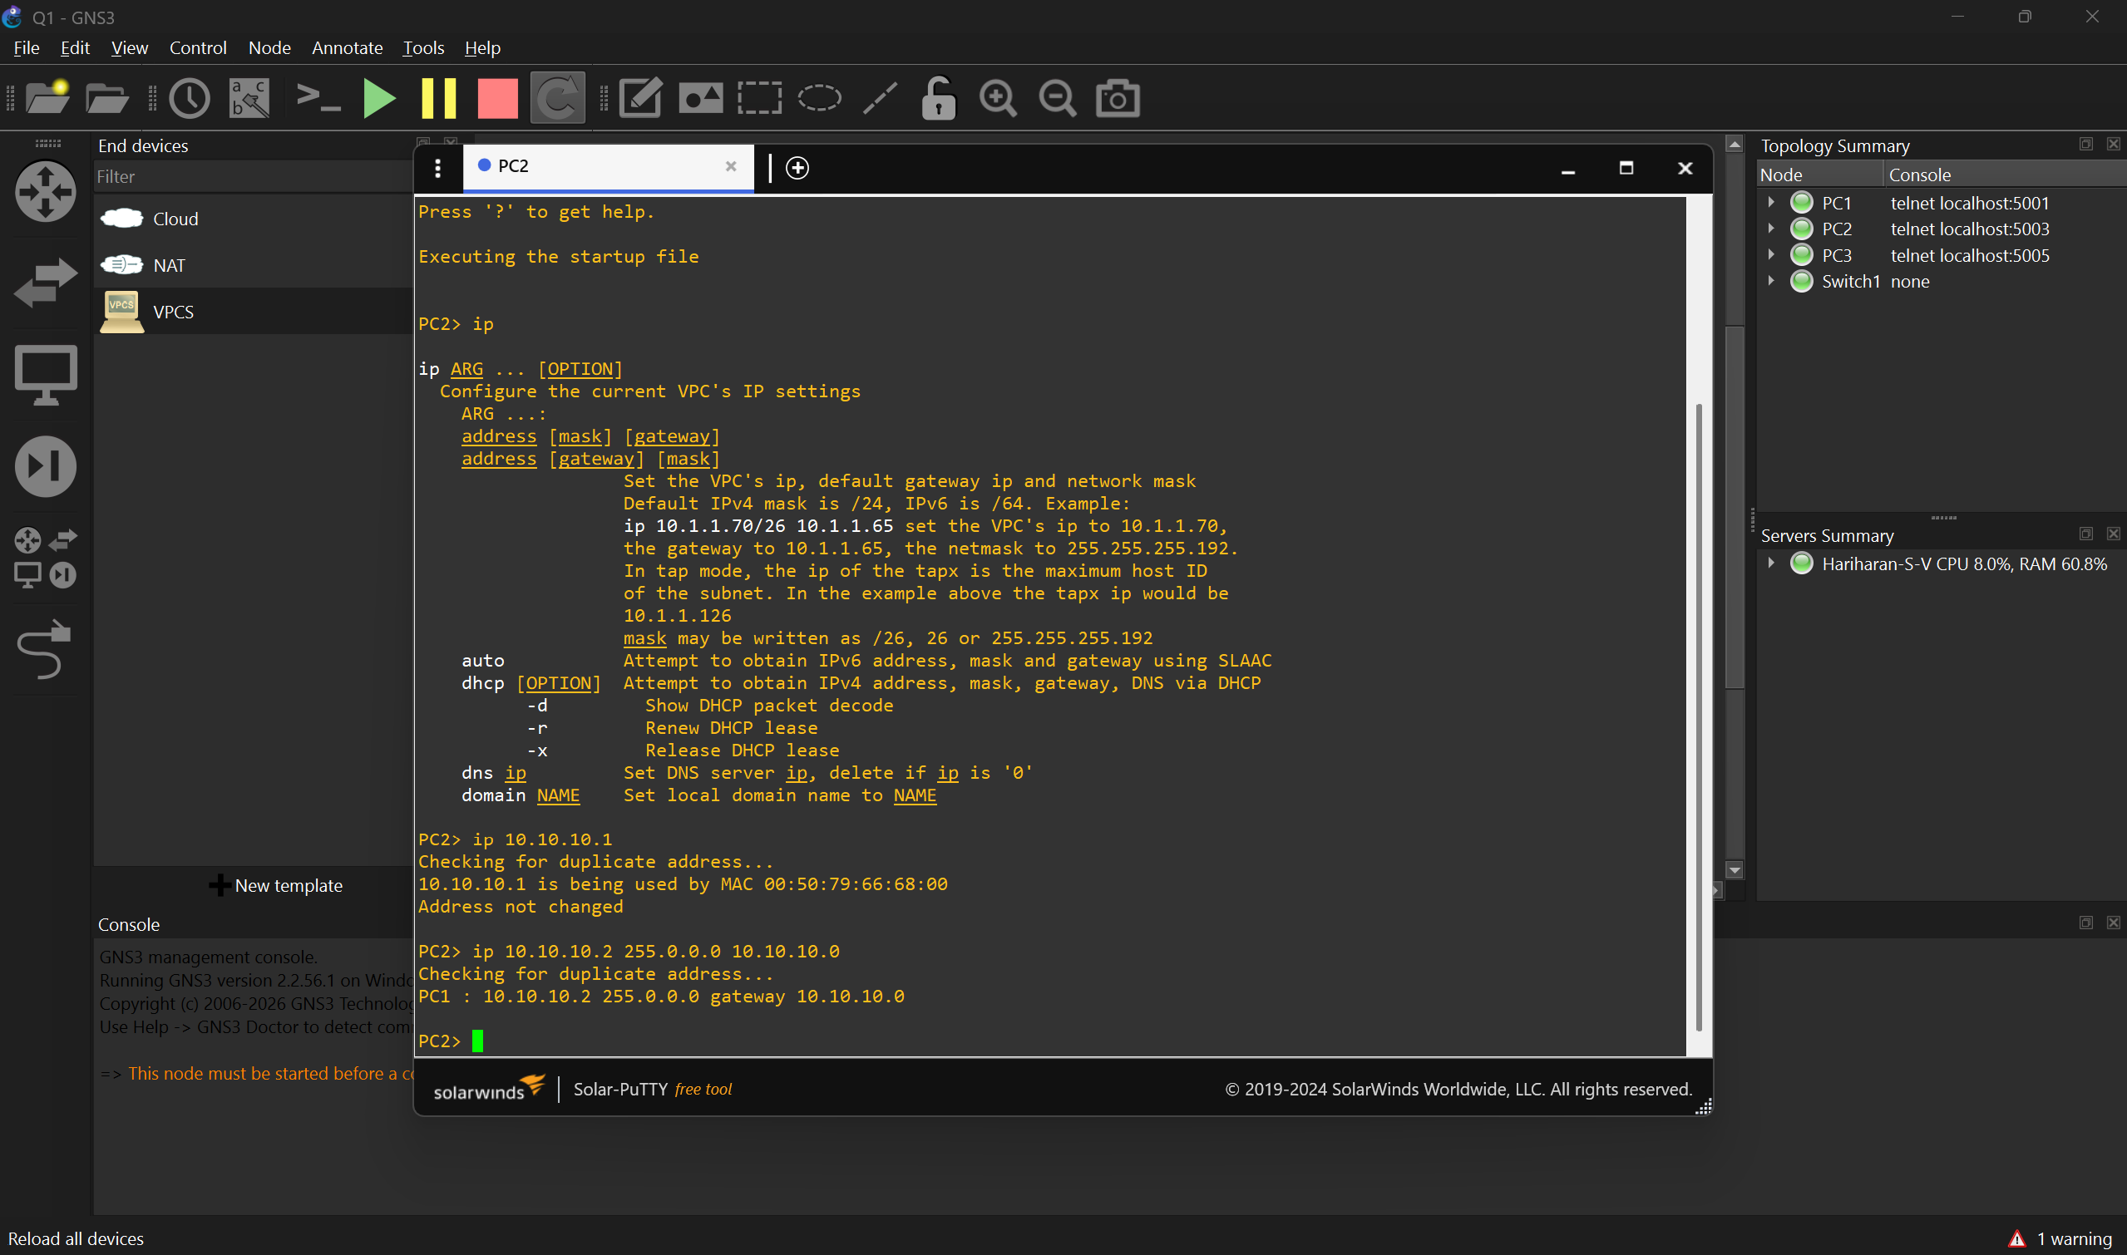
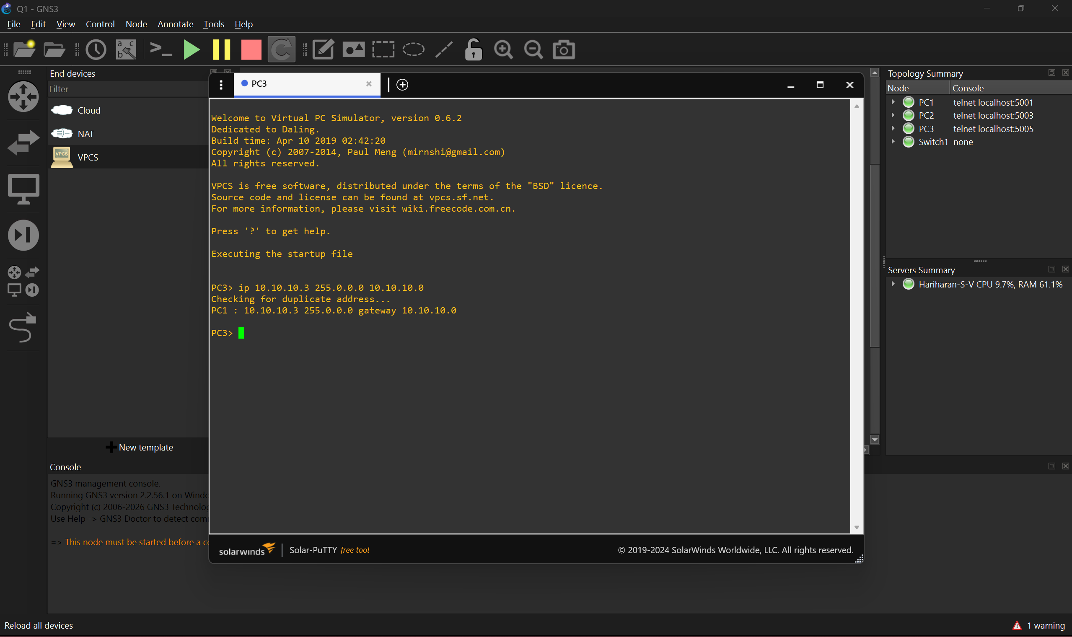
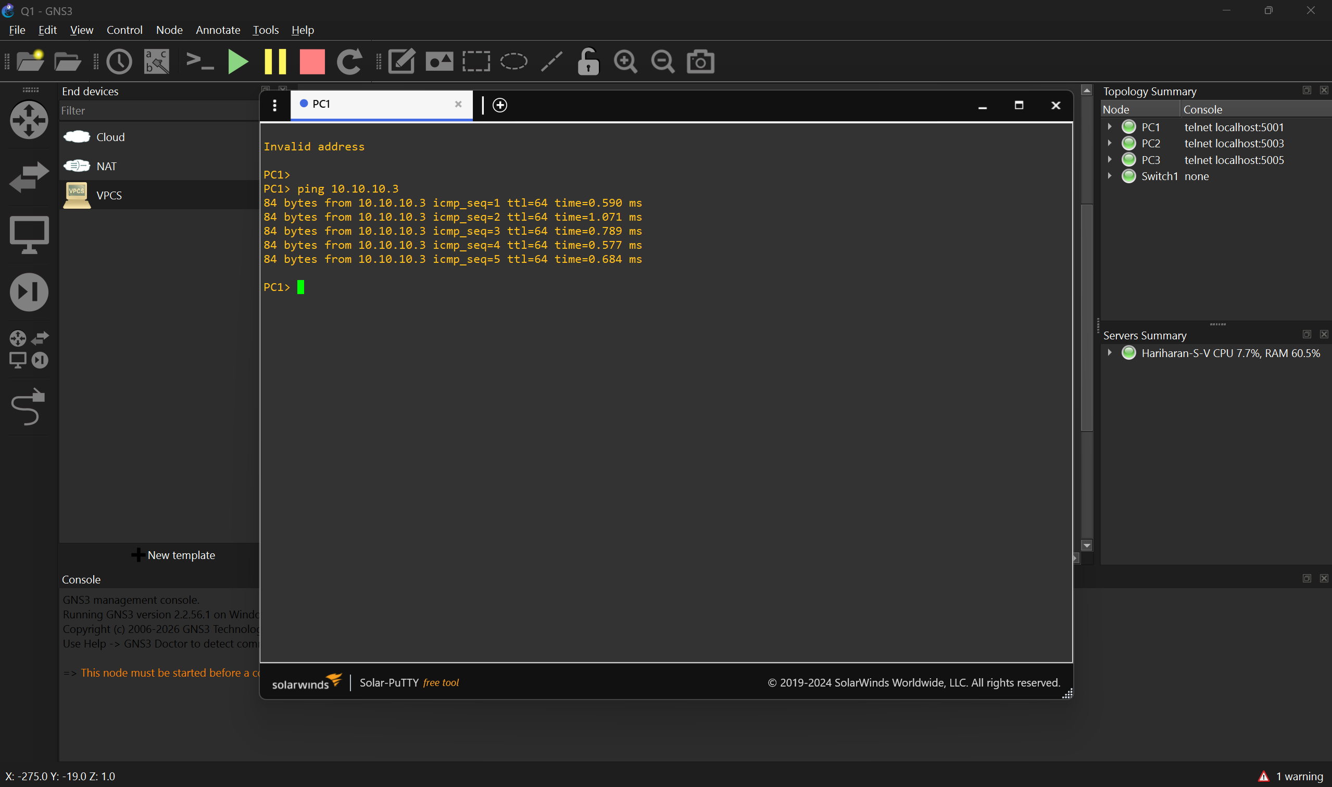
Ping command is given by PC1 to PC3.

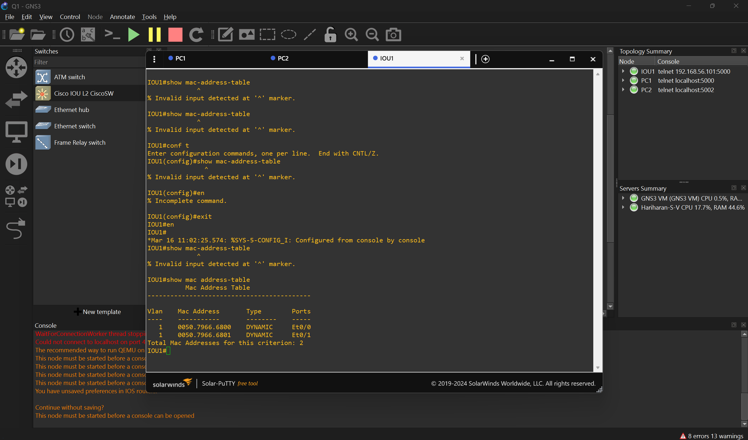
Mac Address Table of the Switch.

- Capture and analyze Ethernet frames using Wireshark.
Inspect the structure of the frame
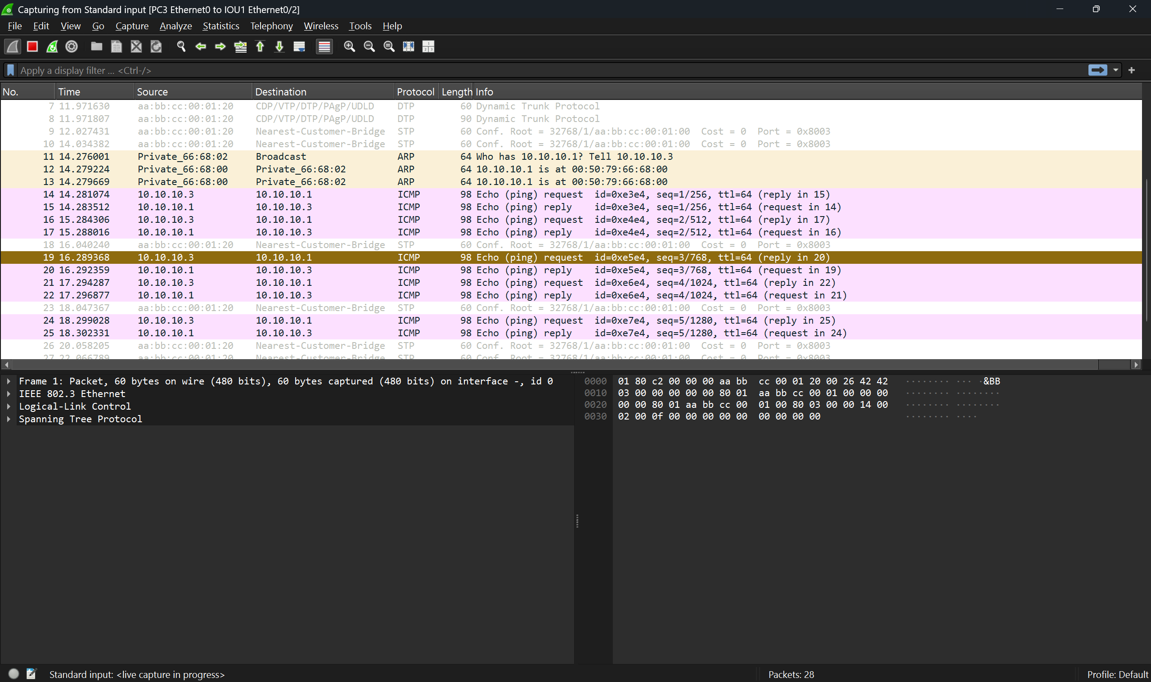

- Configure static IP addresses, modify MAC addresses, and verify network connectivity using ping and ifconfig commands.
